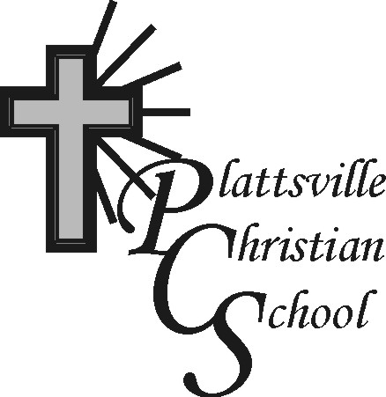

PCS Pulse

December 1, 2024

“Rejoice always, pray continually, give thanks in all circumstances; for this is God’s will for you in Christ Jesus”. 1 Thessalonians 5:16-18



**2** Term Two begins

**6** Hot Lunch (Pizza)

Report Cards go home

Gift Card orders due

**11** Chips for sale at recess(75¢)

**12** Parent-Teacher Interviews

(**Early Dismissal – 11:50 am**)

**13** Hot Lunch (Pizza)

**16** Christmas movie/popcorn in aft.

**17** JK-Gr. 4 visit to Schneider Haus

(Kitchener)

**18** Christmas practice – a.m.

Chips for sale at recess(75¢)

Christmas Crafts in afternoon

**19** Christmas Program

(1:30/6:30 pm)

**20** Pajama and Pancake Day

(**Early Dismissal – 12:00 pm**)

**Dec. 23-Jan. 3** – Christmas Holidays

**Jan. 6** Back to school

**Christmas Program 2024**

We are very excited to present our annual Christmas program

this year! The students are working hard to prepare songs, stories and more for this special event. We will have **two** performances

on **Thursday, December 19 – 1:30 pm and 6:30 pm**.

For the evening performance,

students should be at the school

by 6:10 pm to get ready. We would

love for each family to bring a plate of

nut-free cookies (approx. a dozen) to

share after the event. Merry Christmas!

**Living Books Fair**

Once again, Living Books will be hosting a book fair on our Parent Interview day with some great Christian books, gift items and t-shirts. This will set up in the library area for parents to peruse before or after their interviews. Ann always donates a percentage of her sales on interview day back to PCS.



**Happy December Birthdays**

1. Ezra VW

**4** Harnoor

**11** Zac

**15** Ms. Fischer

**24** Elias

**26** Caia



**Christmas Crafts**

We are looking forward to holding our annual Christmas Craft afternoon here at PCS on Wednesday, December 18. The students will visit a variety of different stations that afternoons and come home with some treasures!

The cost for this year will be $5.00 per student. Information forms will go home on Monday, December 2. Please return all forms by Dec. 9.



**Parent/Teacher Interviews**

**Thursday, Dec. 12**

Reports cards will go home on Friday, December 6th and Parent-Teacher Interviews will take place the following Thursday, Dec. 12. School will be dismissed at 11:50 A.M. to allow for sufficient time to meet with all school families.

Your confirmation interview time will be included with your youngest child’s report card.



**Pajama Day Pancake Breakfast**

Our final school event of 2024 is Friday, December 20. Students can come to school in Pajamas and join with your class for a delicious pancake breakfast!

Students will eat first in the gym. After breakfast, we will gather downstairs

for some carol singing. Students will spend the remaining time having some fun in their classes and will be dismissed at 12:00 p.m. to start their Christmas vacation!

**Christmas Movie!**

On Monday, Dec. 16, the students will be watching a favourite Christmas movie (TBD) in the afternoon – we will have 2 choices for the older students. Popcorn will be provided!!

